IBM Predictive Analytics Service for Bluemix
General Discussion on Application Development

Prepare to Develop the Application
Bluemix makes it very easy to get a new application started. It is worth using the Bluemix ‘create an app’ at least once to get a good feel for what is involved.
- Go to the Bluemix web site. We’ll be using the ‘Development instance’ in this example which is at https://console.stage1.ng.bluemix.net/
- Log in using your account details or sign up now for an IBM ID and access to Bluemix, it is free.
- You may create an ‘org’ and ‘space’ for doing this sample development in, the names used are up to you.
- Once on the dashboard for your development space push the ‘Create an App’ button
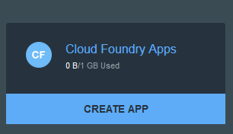
- In this example we will create a NodeJS application but any language capable of making REST service calls will do.
- choose "WEB"
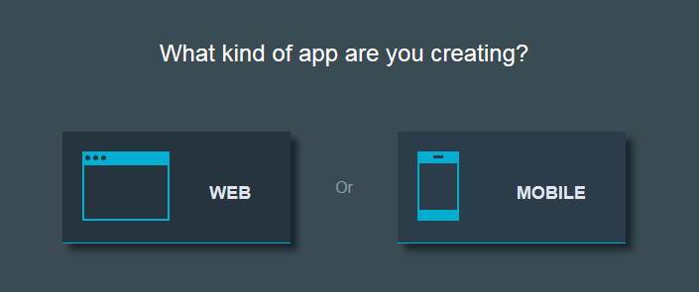
Then choose "NodeJS SDK"
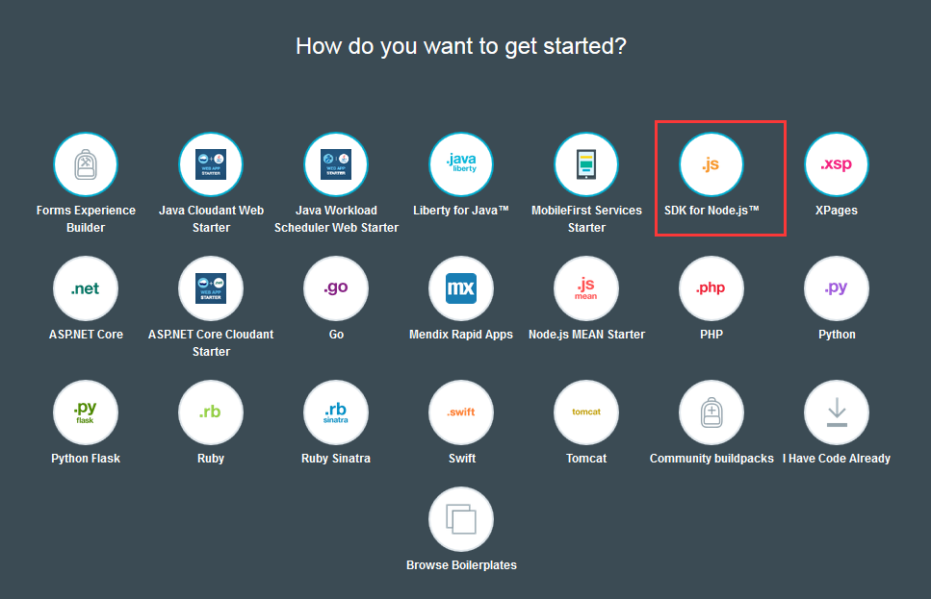

- Then your application will be there and running. It a simpe "NodeJS Starter Application". If you want more features, you could push your own NodeJS code onto this application by either way:
a) CF Command Line Interface
b) GIT
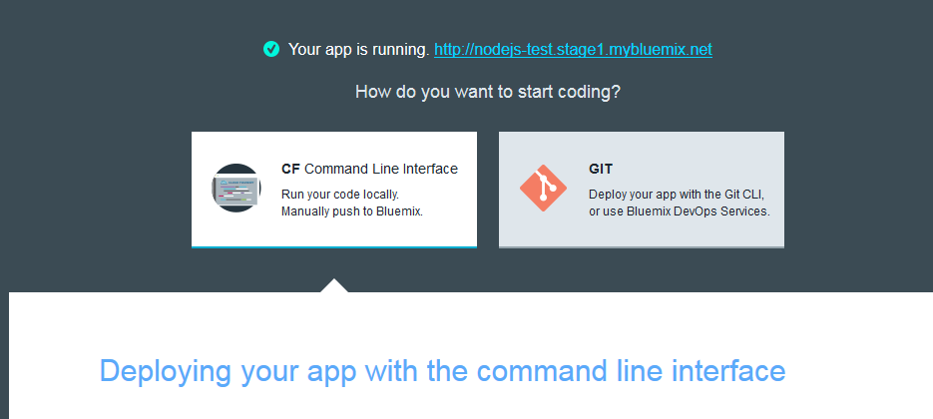
- If we look into the newly deployed application through the URL (it's beside the "Your app is running"), you could see the welcome page. That means your application is successfully deployed.
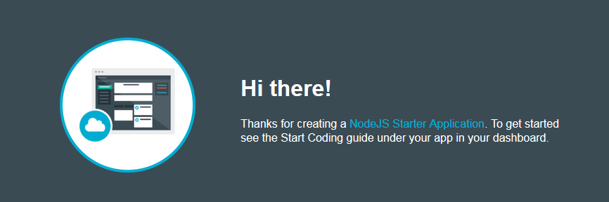
- A number of things happen when you push ‘Create’ on your new application. A viable ‘shell’ application for NodeJS is created and ‘pushed’ out to Bluemix. The DNS routing entries that let you get to this application are entered. Then the application is started, a basic ‘Hello World’. you can see the application in your dashboard.
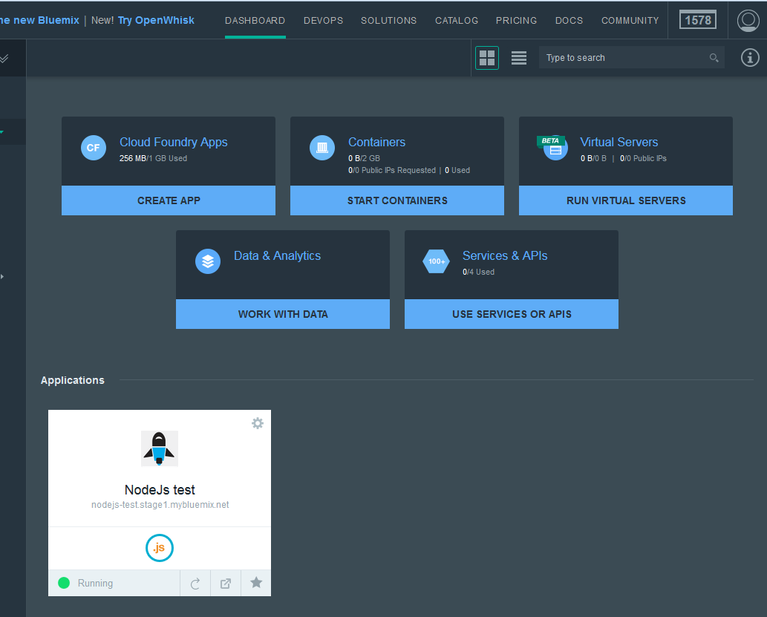

- Click on the application you just deployed, you could see more details.
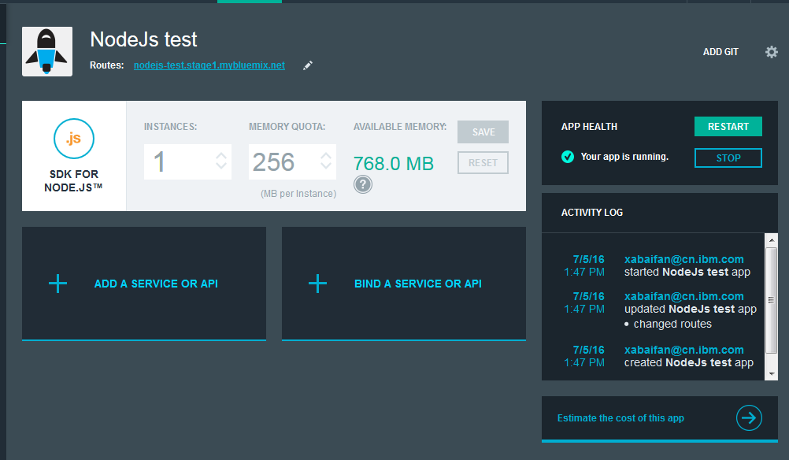
- The fun begins when we download this application and work with in on our desktop. When we select ‘Start coding’ on our application we get a help in installing the CF command line tool and downloading our sample application by clicking on the 'Download the starter code'. But before you do that, please install the Bluemix and CF command line interface, and configure their install directory into your Environment Variable "%Path%".
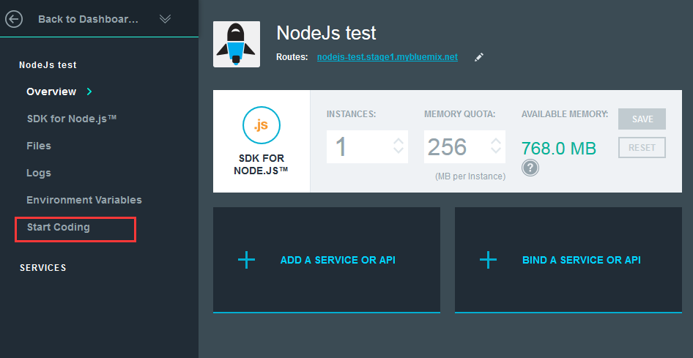

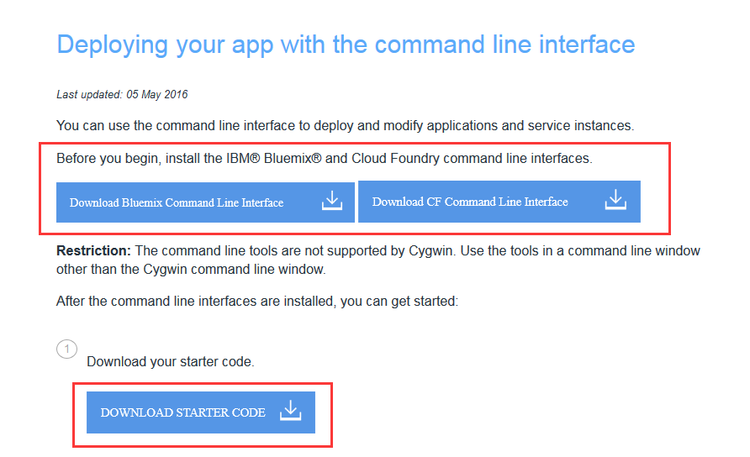

- What is in this application bundle when we download it?
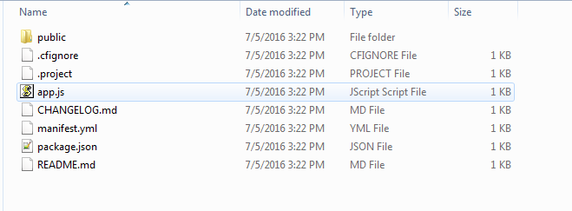
We get the basic framework for a NodeJS application (app.js and package.json) as well as the manifest.yml used when we ‘push’ this application up to Bluemix. There is also a ‘README.txt’ to help you take your next steps in building a NodeJS application.

Push the Modified Application Back to Bluemix
- The following comments (under 'Download starter code' button in Step 11) shows how to push back the application after you modified.
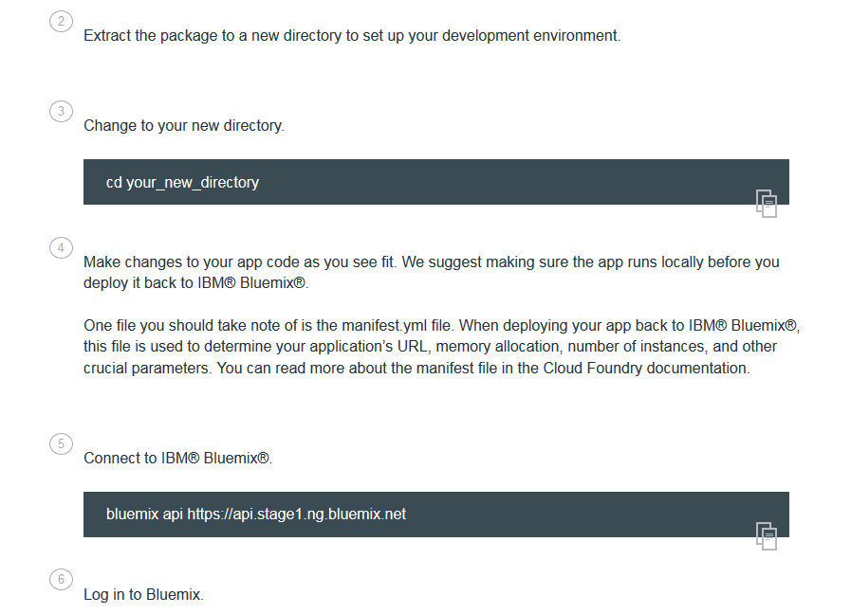
For more details, please see 'VIEW DOCS'
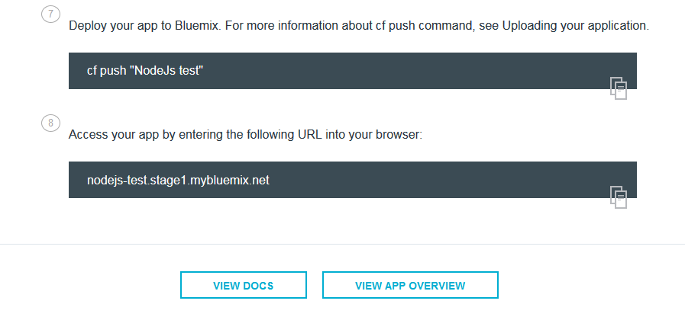

The entire bundle is transferred up to Bluemix and you will be notified as it goes through all phases of deployment and finally restarts.
Once restarted the application can be launched right from the Bluemix dashboard by pushing the ‘open app in a new page’ button.
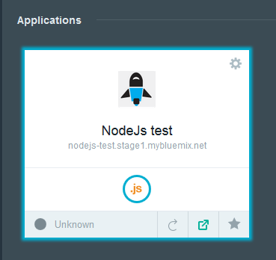

Testing Your Bluemix Application During Development
You may provision an instance of the IBM Predictive Analytics service at any point in time and get the connectivity information you need to test your application from your desktop. You may also ‘push’ your application back up to Bluemix at any point in time and test it there.
To test your application from your desktop you will need a compatible development environment. In the example we’ve been looking at here this would mean a NodeJS server install.
Use the “Add/Bind a Service or API” button on your Bluemix application to connect it to your service instance. "Add a Service or API" means you newly add a service and bind it to your application. "Bind a Service or API" means you bind an existing service or API to your application.
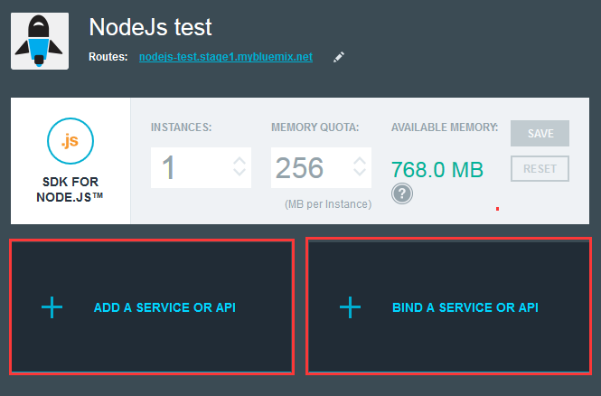
Since it's the first time we use it, please choose "Add a Service of API".
In "Data and Analytics" category, find "Predictive Analytics"
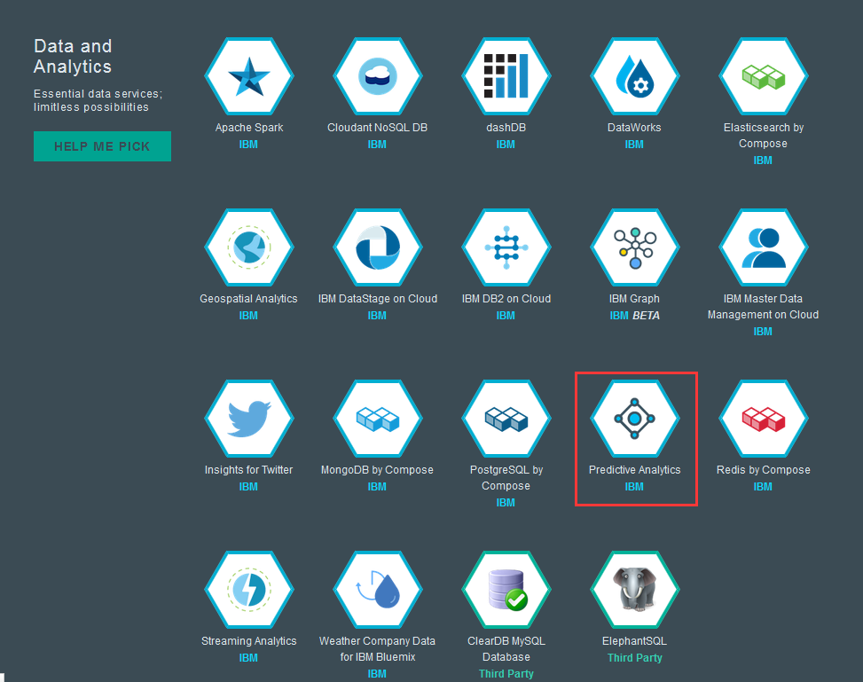
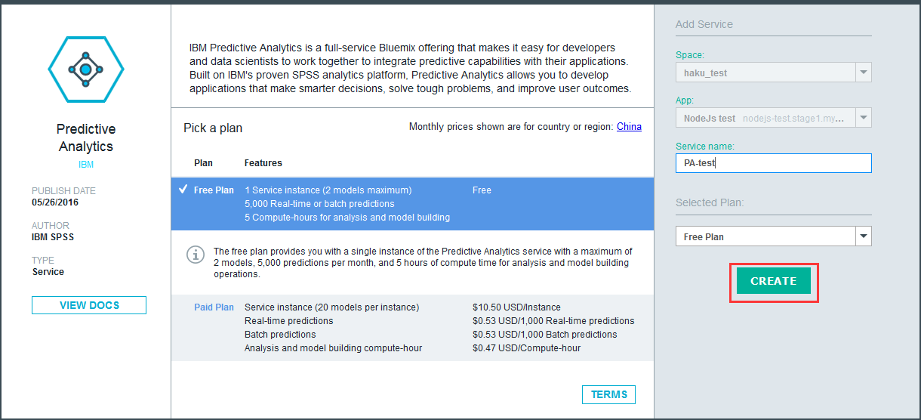
Set your service name and fee plan, click on "Create". Now the service is created and bound to your application. You may click on the "Restage" button to restage your application and let the bound service work.

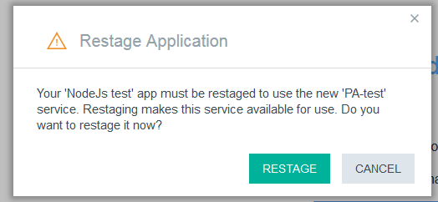
Go to application "Overview" page you could see the bound service. Once the application is bound you can click on the “Show Credentials” button on the bound service icon to get the connectivity information you need to test your application from your desktop.
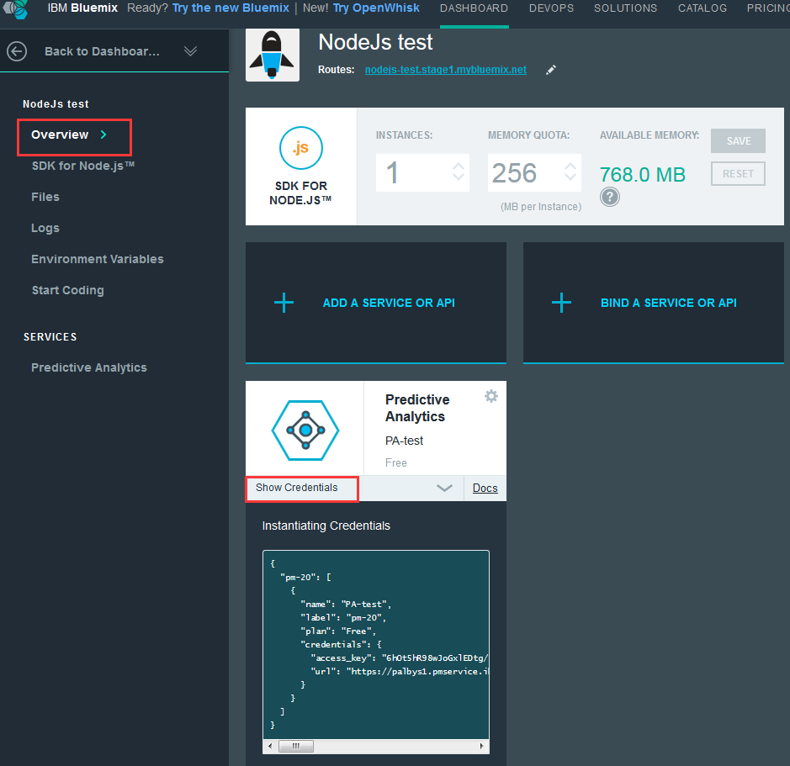
Modify the NodeJS example app.js file to use either the Bluemix provided environment vairables VCAP_APP_HOST, VCAP_APP_PORT and VCAP_SERVICES or values you set to test from your desktop.
Please read the docs under Sample1 and Sample2 folder to know how the Sample1 and Sample2 works.
IBM Predictive Modeling Service for Bluemix - Sample1.doc and IBM Predictive Modeling Service for Bluemix - Sample2.doc

